ST. XAVIER’S COLLEGE

**(Affiliated to Tribhuvan University)**

**Maitighar, Kathmandu**



**Computer Graphics**

**Lab Assignment # 7**

**Translation, Rotation & Scaling in C++ Builder**

**SUBMITTED BY:**

**Apil Neupane**

**013BSCCSIT008**

**SUBMITTED TO:**

|  |  |
| --- | --- |
| **Er. Anil K. Sah**  **Lecturer** |  |
| **Department of Computer Science** | |

Submission Date: 1stSeptember 2015

**STATEMENT**

**Write a program to translate the given image using C++ Builder.**

**SOURCE CODE:**

//---------------------------------------------------------------------------

#include <vcl\vcl.h>

#include<math.h>

#pragma hdrstop

#include "Unit1.h"

//---------------------------------------------------------------------------

#pragma resource "*.dfm"

TForm1 *Form1;

//---------------------------------------------------------------------------

__fastcall TForm1::TForm1(TComponent* Owner)

: TForm(Owner)

{

}

//---------------------------------------------------------------------------

void __fastcall TForm1::MagicClick(TObject *Sender)

{

int x=Image1->Width;

int y=Image1->Height;

int Tx=StrToInt(Edit1->Text);

int Ty=StrToInt(Edit2->Text);

for(int i=0; i<=x; i++)

{

for(int j=0; j<=y; j++)

{

int a=i+Tx;

int b=j+Ty;

Image2->Canvas->Pixels[a][b]=Image1->Canvas->Pixels[i][j];

}

}

}

//---------------------------------------------------------------------------

void __fastcall TForm1::RotateClick(TObject *Sender)

{

int x=Image1->Width;

int y=Image1->Height;

int deg=StrToInt(Edit3->Text);

float rad=deg/180.0*3.141592;

for(int i=0; i<=x; i++)

{

for(int j=0; j<=y; j++)

{

int a=(i*cos(rad)-j*sin(rad)+200);

int b=(j*cos(rad)+i*sin(rad)+200);

Image2->Canvas->Pixels[a][b]=Image1->Canvas->Pixels[i][j];

}

}

}

//---------------------------------------------------------------------------

void __fastcall TForm1::ScaleClick(TObject *Sender)

{

int x=Image1->Width;

int y=Image1->Height;

int Sx=StrToInt(Edit4->Text);

int Sy=StrToInt(Edit5->Text);

for(int i=0; i<=x; i++)

{

for(int j=0; j<=y; j++)

{

int a=i*Sx;

int b=j*Sy;

Image2->Canvas->Pixels[a][b]=Image1->Canvas->Pixels[i][j];

}

}

}

//---------------------------------------------------------------------------

**OUTPUT:**

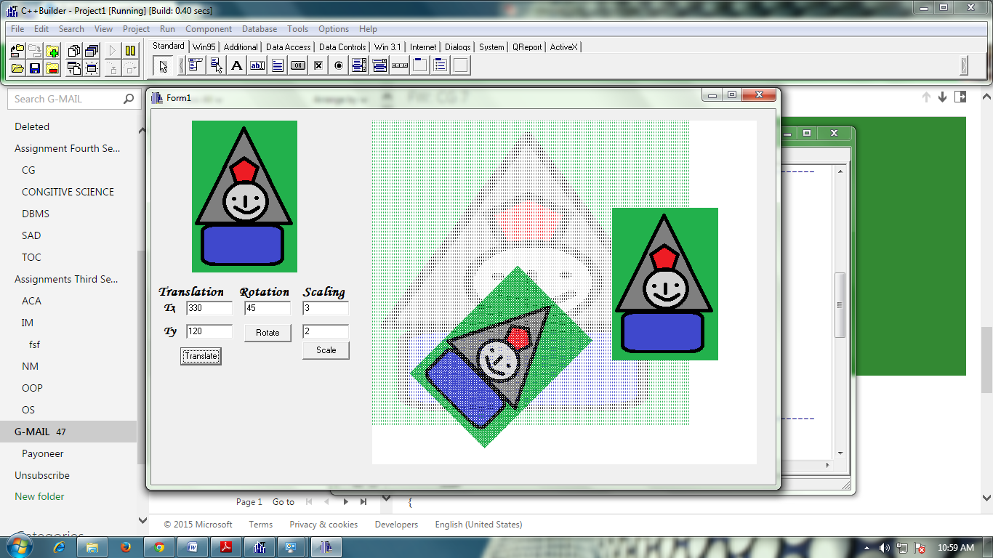

**CONCLUSION:**

Hence, the given image was translated, rotated and scaled by using C++ Builder.